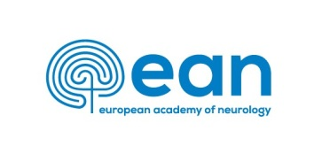

Clinical Fellowship 2021
Application Form

All electronic documents can be received throughout the entire
year 2020, but not later than: October 31, 2020

First name: Last Name:
Title:
Date of birth (dd/mm/yyyy):
Complete contact address:
Street, No.:
Zip code (post code): City:
Country:
Telephone:
e-mail:

I have already contacted the following department and attach the acceptance form:
Name of Department:
Name of Head of Department:
Mentor during fellowship:
Hospital:
Address:
City: Country:
e-mail mentor:
Expected duration (in weeks: min 6, max 12): _____ weeks
Justification: why applying for a stay longer than 6 weeks:

Declaration of eligibility:
I certify that, at the time of this application:
I am a neurology resident and RRFS member from an EAN member country/
Corresponding Institutional Member Country / live and work in an EAN member country
and have at least 2 years of clinical training
I am a Full member within 5 years after completion of neurology training and apply for
this special programme to learn a new application or technique not available in my home
department

-----------------------------------------------------
Signature

Explanation
Why and how the clinical fellowship in that particular Host Department is relevant to me, objectives and expected gains:

IMPORTANT: The application form must be accompanied by:
- Letter of Acceptance from the approved host department
- EAN CV form
- Evidence of training/experience; EAN membership certificate
- 2 letters of recommendation (in addition to the host acceptance letter)
- Copy of passport/Identification card

Applications should be sent:
by e-mail to Ms. Magda Dohnalová: fellowship@ean.org

Applications must be typed, and not handwritten!
The maximal size of all attachments together is up to 5MB.
We accept documents:
- application form – word format (only)
- other documents in word, pdf, jpg formats

! Incomplete applications will not be accepted !

